**Deployment Diagram**

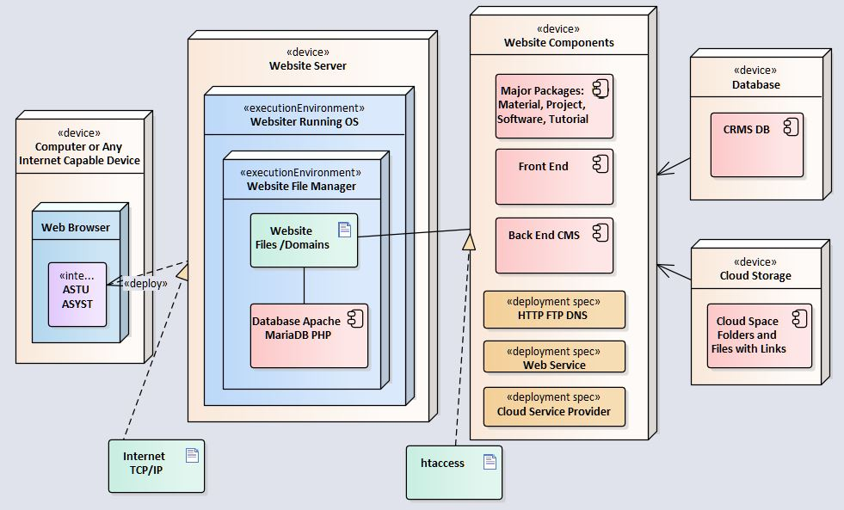

**Global Software Control**

Global software control describes how the global software control is implemented. In particular, this section should describe how requests are initiated and how subsystems synchronize. This section should list and address synchronization and concurrency issues.

The following section will describe the software control implementation.

External control flow (between subsystems)  
• *Control flow is distributed within the CRMS system. This means that there is no central control instance.*• *Each service has its own control flow with PHP page constraint, cookie assignment and session callback.*• *Services request input (”needs”), wait for it and resume control when it arrives.*• *The services use asynchronous callbacks to communicate with each other.*  
Concurrent control  
*The CRMS content management system handles communication between single services and balances abilities and needs of the services. Failure of one service must not affect the service manager and the other services.*  
• Multithreading  
*the service manager uses threads, so that a large number of services is able to use the  
service manager simultaneously. The service manager also handles asynchronous events  
within the system.*  
Internal control (within a single process)  
• *Avoiding Deadlocks*

*Processes must not callback a running service; in order to maintain a dead-lock free environment.*• *Worker Threads for Each Service  
each service has an own thread for communication, which communicates with the service  
manager and other services.*

**Boundary Conditions**

Boundary conditions describes the start-up, shutdown, and error behavior of the system. One of the main proposals of Boundary Conditions is to describe how the whole system can be started, what services have to be initializes first.

Startup

The system in this case the website starts with composer JSON trigger of index page providing the home page with navigation to other pages. The subsidiary pages would round up to the “href” reference and get redirected accordingly.

The instructor and administrator subdomains also must initialize as the privileged users need to access the backend CMS at any given time with session configurations.

Termination

As primary users close the website’s tab, the system returns to halt for that particular request; yet hold an active state for next website call.

As administrators and instructors logout of the backend CMS, the system directs the browser to dump all the sessions to null and release all cookies to cache.

Failure

As a non-existing link is entered in the system, the system routes to the pre-set 404 page using the .htaccess ERROR DOCUMENT. The PHP and html tags are routed to a shorter URL for security purposes. In case of connection error or Server failure provide an interruption page for the users to visit the website later on.

|  |  |  |
| --- | --- | --- |
| Error | Cause | Forecast Solution |
| Website GUI not working | Could be many internal causes | Try again later or use a plugin. |
| Some fatal errors | Malware | Scan with malware scanner |
| Internet not working | Improperly configured APN settings. No internet from the user internet service provider (ISP). | Properly configure internet connection settings as well as proxy if necessary. |
| Server Not found | Internet connection fail | Make sure Network connection or firewall (proxy) protection settings are correct. |